Digit Sum
Platform: HackerEarth
Language: C
Module 4, Question 1

Problem Link
https://www.hackerearth.com/problem/algorithm/digit-sum-4/

Problem Statement
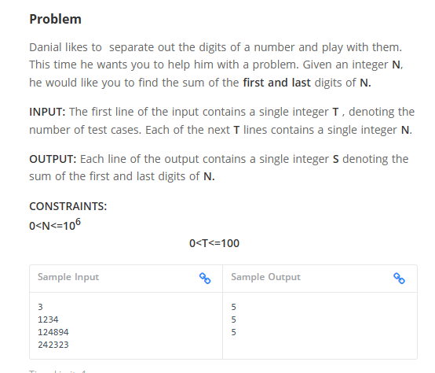

C Code
#include <stdio.h>

int main() {
int t;
scanf("%d", &t); // number of test cases

while (t--) {
long long n;
scanf("%lld", &n);

int last = n % 10; // last digit
while (n >= 10)
n /= 10; // keep removing digits until one is left
int first = n; // first digit

printf("%d\n", first + last);
}
return 0;
}

Screenshot of Successful Submission



